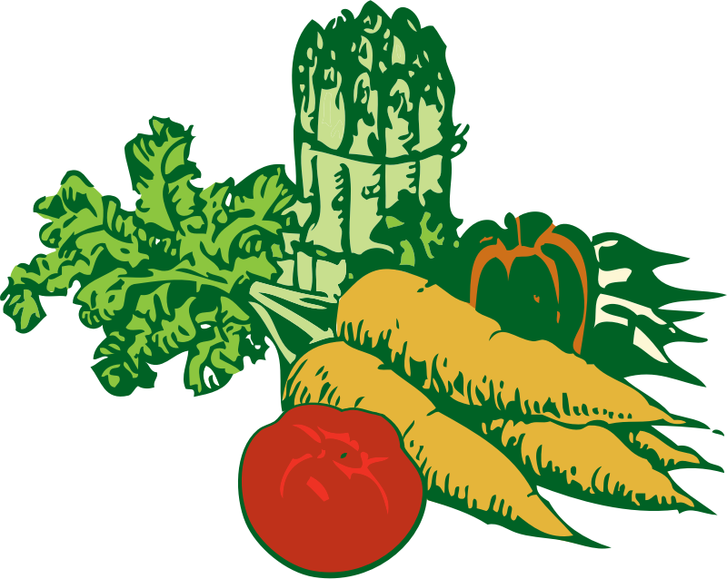
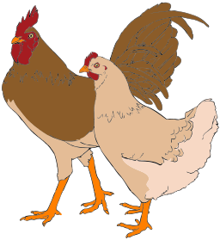
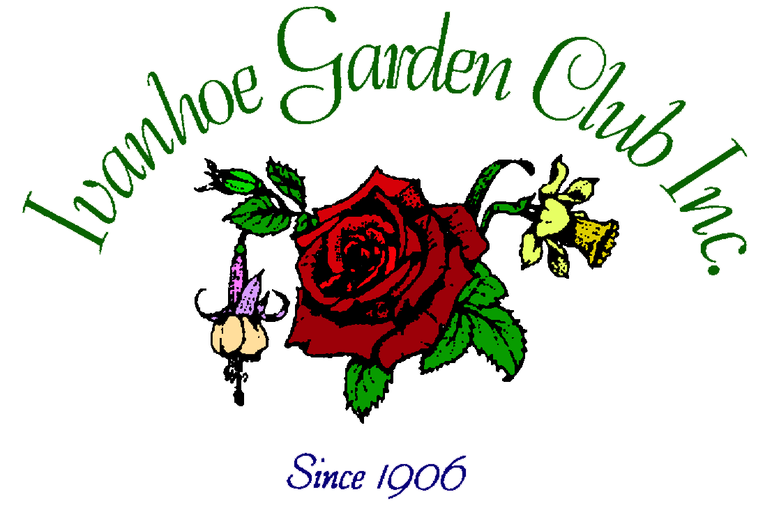
29th October 2017
FESTA
Noon to 4.00 pm
Bellfield Community Centre
Corner Oriel Road and Banksia Street, Ivanhoe

Displays and demonstrations from a range of garden groups and societies
Sales – Plants and Seedlings, Collector’s Table, White Elephant, Children’s Activities, Devonshire Tea and Sausage Sizzle

Unusual Potted Container Competition – Open to All
All enquiries to the Secretary Julie Stafford: 9499 4659/0401 161 461

