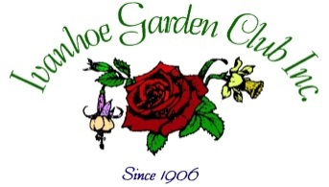
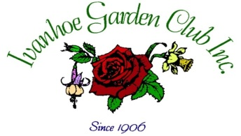
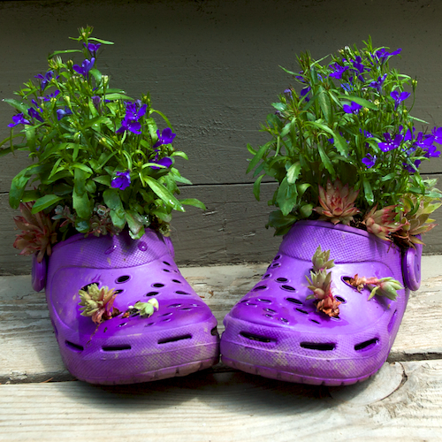
Unusual Potted Container Competition
The Ivanhoe Garden Club is conducting an unusual potted container competition as part of its upcoming FESTA on 23 October 2016.
Prizes!

Entry is free.

Containers must be in place at the Bellfield Centre on the corner of Oriel Road and Banksia Street between 10.30 am and 11.30 am on October 23

Enquiries to
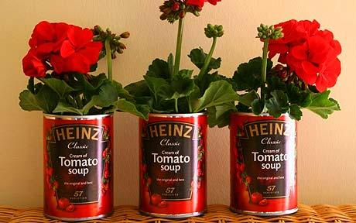
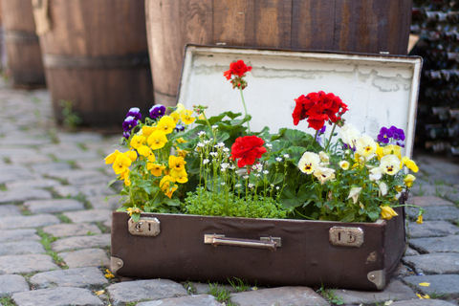
Susan La Marca Ph. 9459 2147

